Lab 1

**Problem 1.** Which of the following functions are increasing? eventually nondecreasing?

1. f(x) = -x2  **FALSE**

b. f(x) = x2 + 2x + 1 **FALSE**

c. f(x) = x3 + x **TRUE**

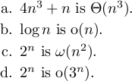**Problem 2.** Use the limit definitions of complexity classes given in class to decide whether each of the following is true or false, and in each case, prove your answer.

**SOLUTION:**

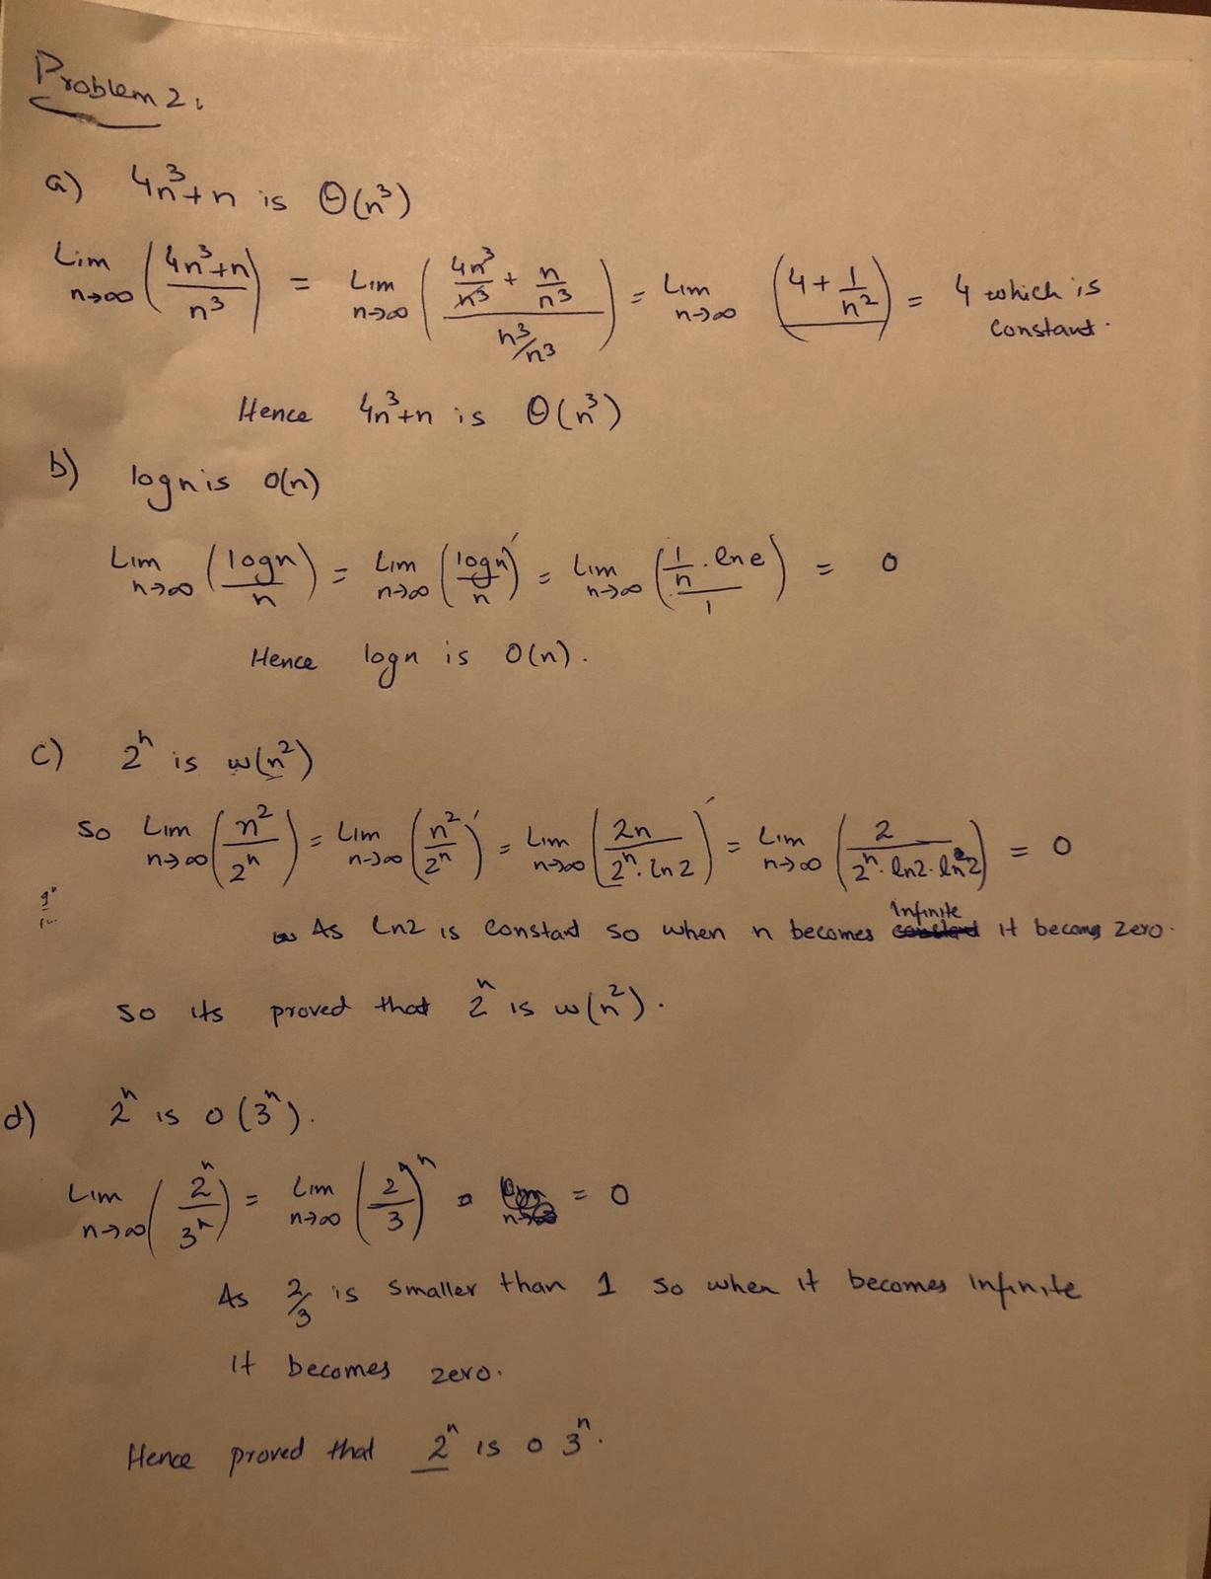

**Problem 3.** Show that for all n > 4, 2n < n!. Hint: Use induction.

**SOLUTION:**

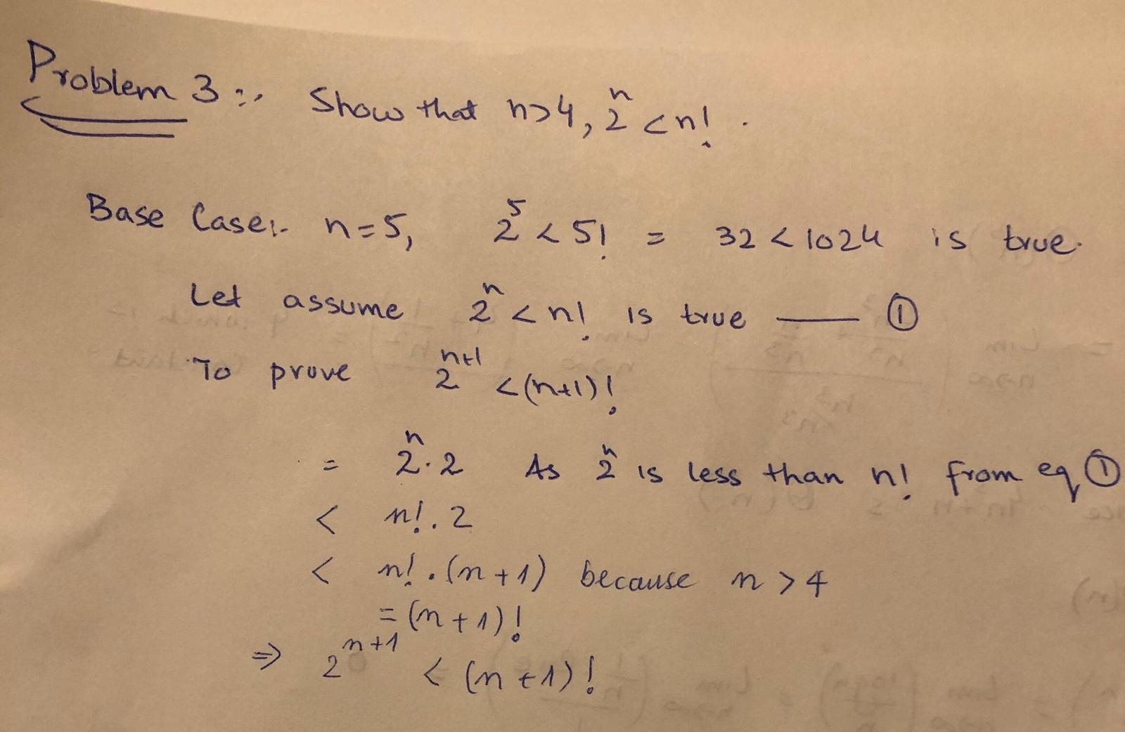

For problems below, write Java programs that solve these problems as efficiently as possible.

**Problem 4.** GCD Problem: Given two positive integers m, n, is there a positive integer d that is a factor of both m and n and that is bigger than or equal to every integer d’ that is also a factor of m and n?

Write a Java method int gcd(int m, int n) which accepts positive integer inputs m; n and outputs the greatest common divisor of m and n.

Examples

* If m = 12 and n = 42, return 6
* If m = 7 and n = 9, return 1

**SOLUTION:**

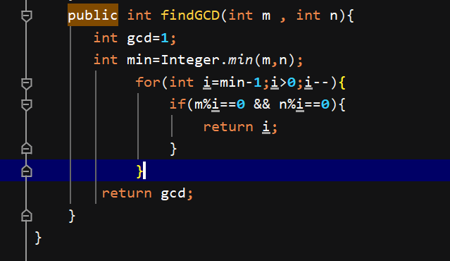

**Problem 5.** Implement the following Java method.

public static int secondSmallest(int[] arr) { if(arr==null || arr.length < 2) {

throw new IllegalArgumentException("Input array too small");

}

//implement

}

This method returns the second smallest element of the input array.

Examples

* If input is [1, 4, 2, 3], return 2.
* If input is [3, 3, 4, 7], return 3. (Smallest is 3, and second smallest is 3.)
* If input is [9], your program will throw an exception.

**Solution:**

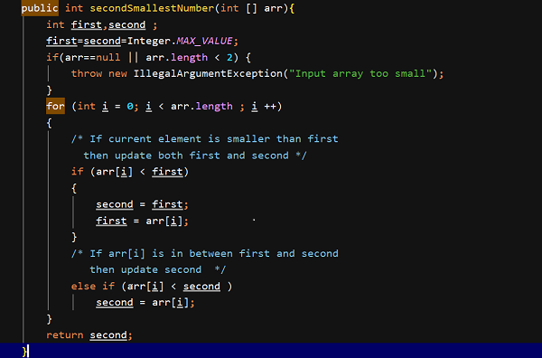

**Problem 6.** SubsetSum Problem: given a set S = {s0, s1,s2, …, sn-1}of positive integers and a non-negative integer k, is there a subset T of S so that the sum of the integers in T equals k?

Formulate your own procedure for solving the SubsetSum. Think of it as a Java method subsetsum that accepts input S and k, and outputs a subset T of S with the property that the sum of the elements in T is k if such a T exists, or null if no such T can be found.

Examples

* If S is [1, 3, 9, 4, 8, 5] and k = 21, return [9,4,8] (since 9 + 4 + 8 = 21)
* If S is [1, 3, 9] and k = 5, return null (since no such subset can be found)
* If S is [1, 3, 9, 4, 8, 5] and k = 0, return [] (since the sum of the empty set is 0)

**SOLUTION:**

